

**Parallel & Distributed Computing [Y1]**

LAB MANUAL/REPORT





Hamad saleem

f2021376065

Mian Muhammad Bilal

[F2021408054]

Muhammad Talha

[F2021408057]

**LAB MANUAL**

**Matrix Operations:**

The parallelized matrix multiplication code uses OpenMP to distribute the computation of matrix elements across multiple threads. Each thread computes individual elements of the result matrix by summing the products of corresponding elements from the input matrices.

When race conditions occur, the results of these operations can become unpredictable due to unsynchronized access to shared data.

**With the Race condition**

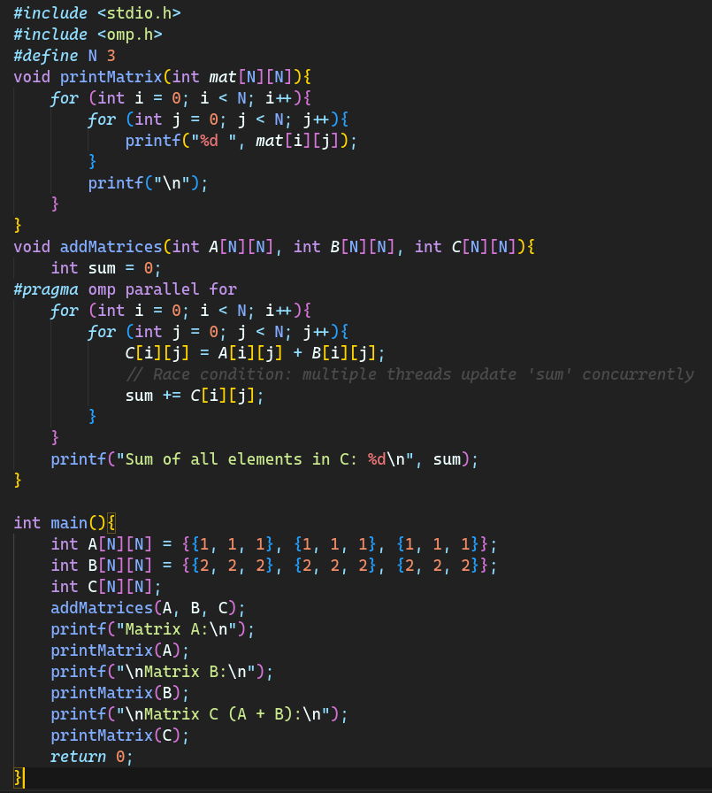**Code:**

**Output:**

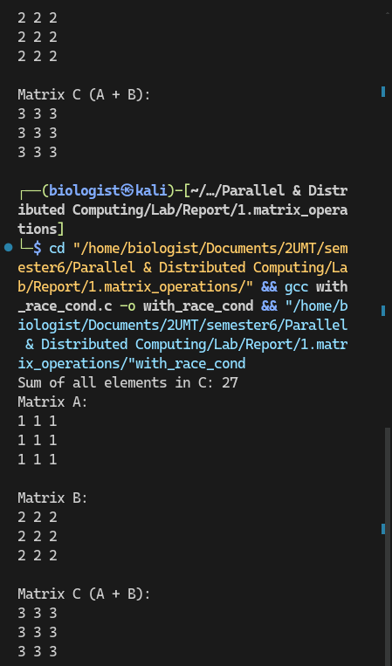

**Without the Racing condition:**

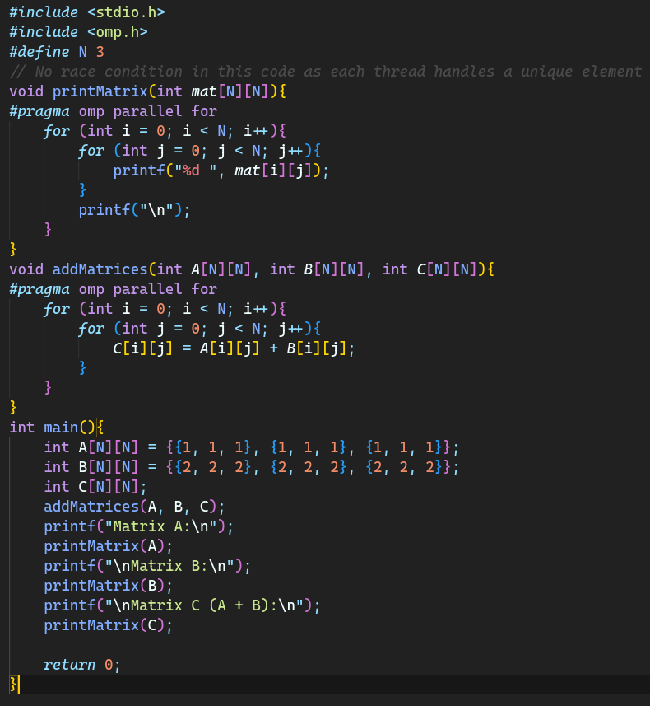**Code:**

**Output:**

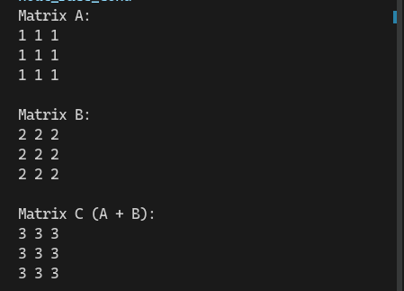

**Prefix Sum:** The parallelized prefix sum code leverages OpenMP to divide the array into segments processed by different threads. Each thread calculates partial sums for its segment, and synchronization mechanisms are used to ensure that the cumulative sums from previous segments are correctly included.

**With the Race condition:**

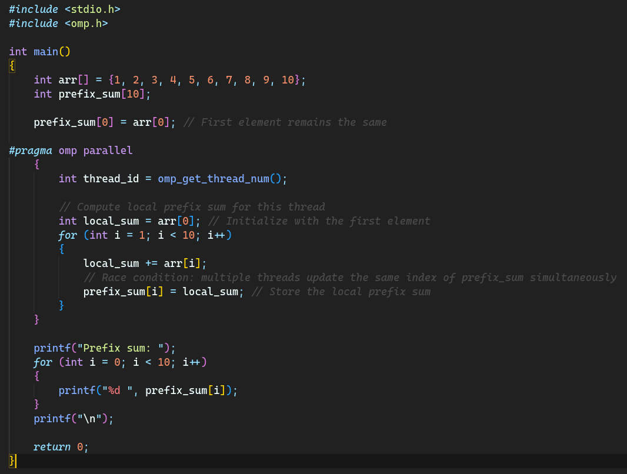**Code:**

**Output:**

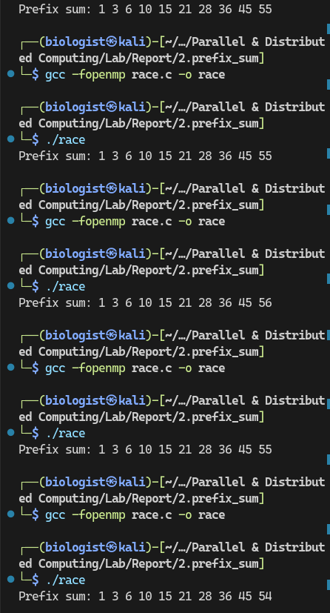

**Without the Racing condition**

**Code:**

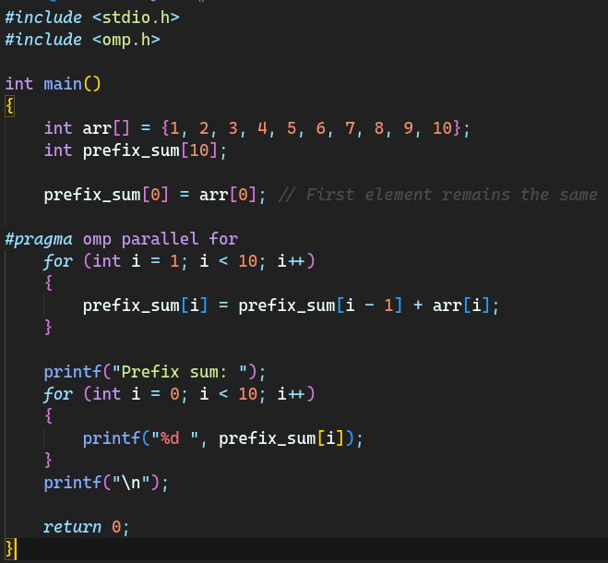

**Output:**

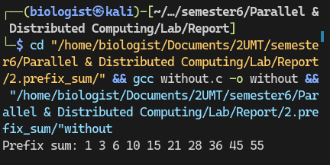

**Recurrence Sum:**

In the parallelized recurrence sum code, each thread computes its partial sum of elements based on the recurrence relation. To prevent race conditions, critical sections or other synchronization mechanisms are employed to ensure that concurrent updates to shared variables are properly coordinated. This coordination guarantees the correctness of the computed sum.

**With the Race condition**

**Code:**

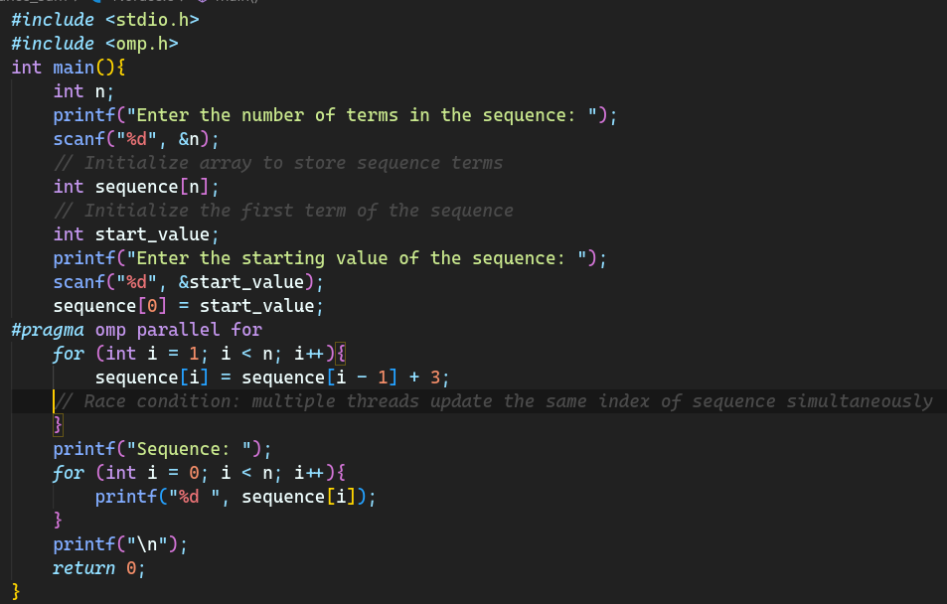

**Output:**

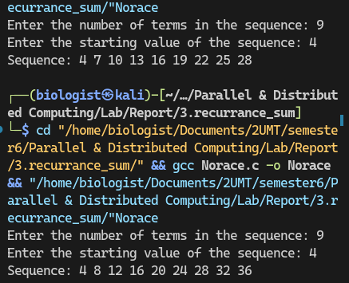

**Without the Racing condition**

**Code:**

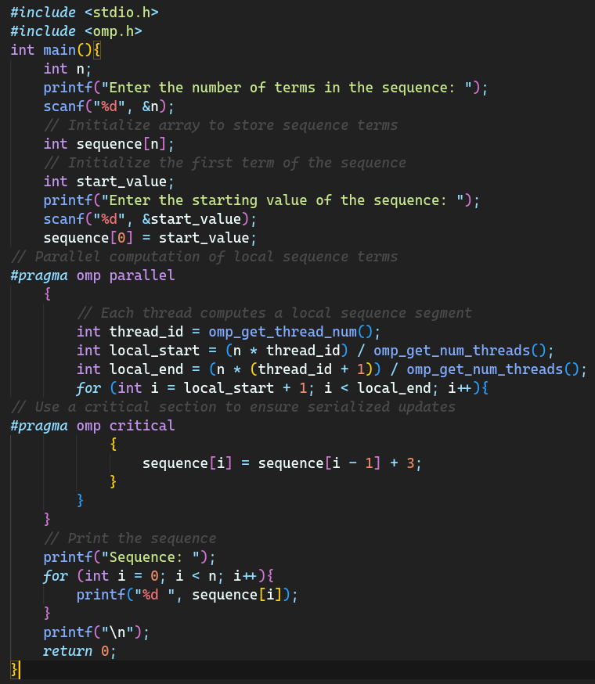

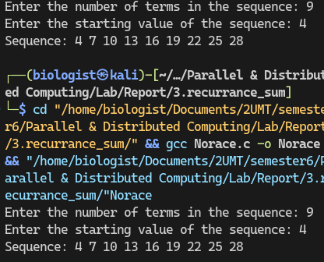**Output:**

**Depth First Search (DFS):**

DFS is a graph traversal algorithm that explores as far as possible along each branch before backtracking. It's used to traverse or search for nodes in a graph or tree structure.

When race conditions occur, the results of these operations can become unpredictable due to unsynchronized access to shared data.

**With the Race condition**

**Code:**

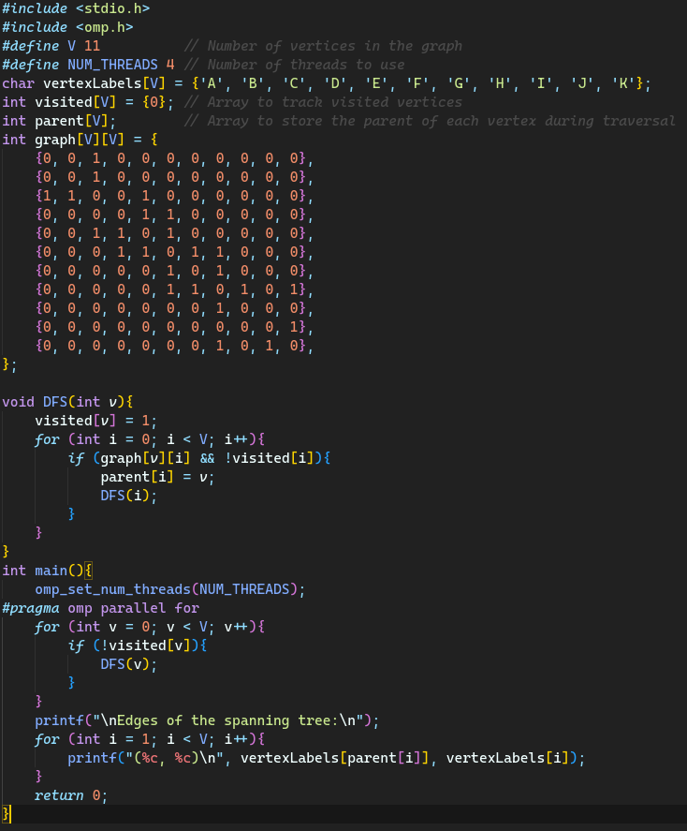

**Output:**

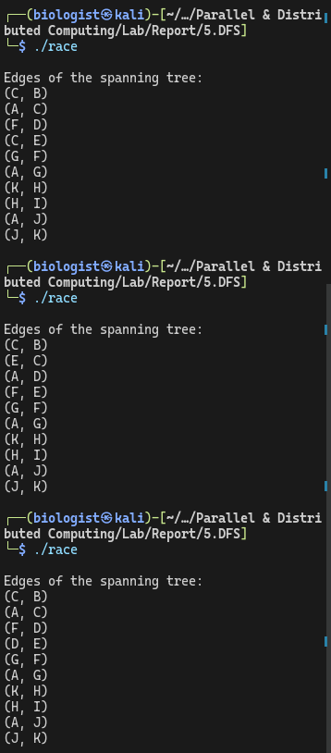

**Without the Racing condition**

**Code:**

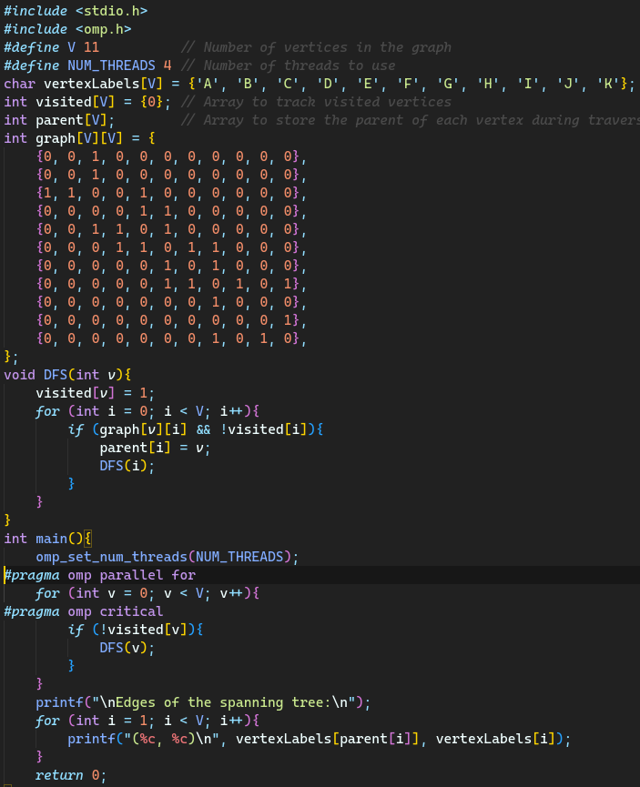

**Output:**

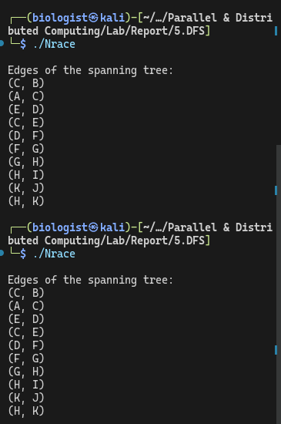

**Breadth First Search (BFS):**

**With the Race condition**

DFS is a graph traversal algorithm that explores as far as possible along each branch before backtracking. It's used to traverse or search for nodes in a graph or tree structure.

When race conditions occur, the results of these operations can become unpredictable due to unsynchronized access to shared data.

**Code:**

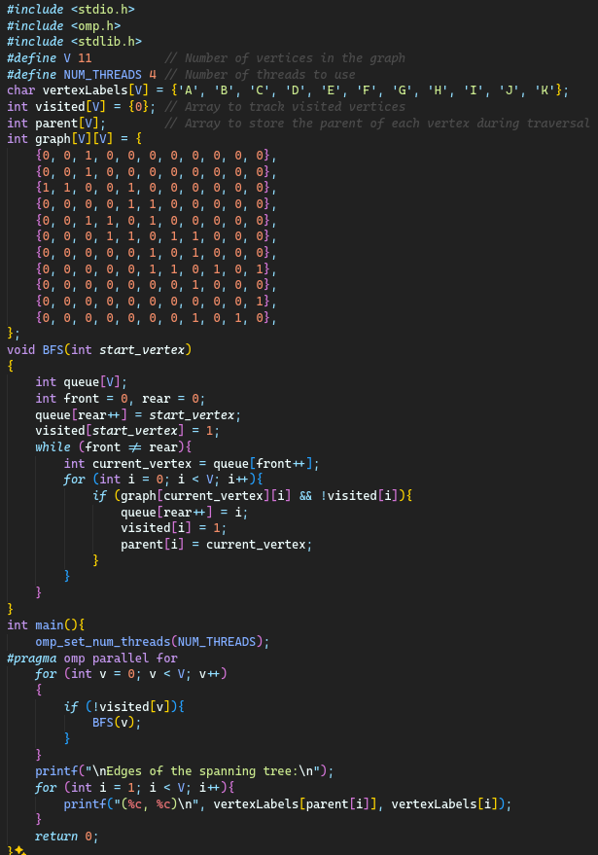

**output:**

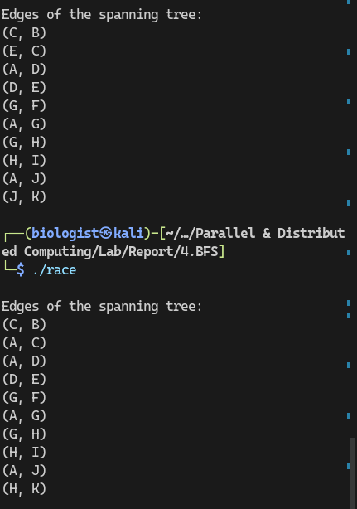

**Without the Racing condition**

**Code:**

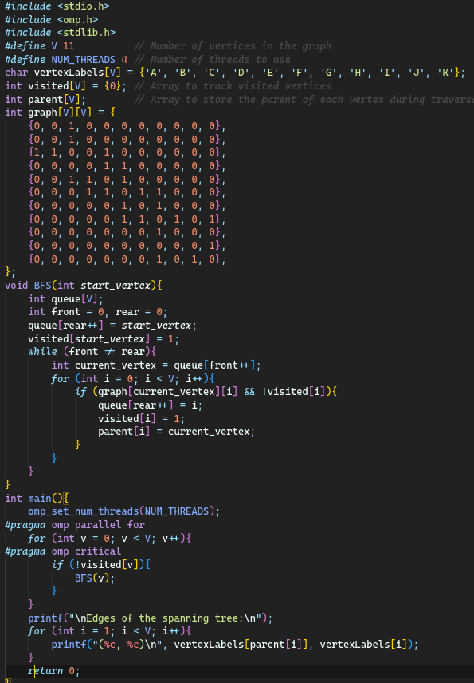

**Output:**

